**Software Requirements Specification (SRS)**

**Project Title:** IBMS (Inventory and Billing Management System)

**Version:** 1.0

**Date:** July 9 2025

**Prepared By:** Jayakrishnan J

**Table of Contents**

1. Introduction  
   1.1. Purpose  
   1.2. Document Conventions  
   1.3. Intended Audience and Reading Suggestions  
   1.4. Project Scope  
   1.5. Definitions, Acronyms, and Abbreviations
2. Overall Description  
   2.1. Product Perspective  
   2.2. Product Functions  
   2.3. User Characteristics  
   2.4. Constraints  
   2.5. Assumptions and Dependencies
3. Specific Requirements  
   3.1. Functional Requirements  
   3.1.1. [Feature 1 Name]  
   3.1.2. [Feature 2 Name]  
   ...  
   3.2. Non-Functional Requirements  
   3.2.1. Performance Requirements  
   3.2.2. Security Requirements  
   3.2.3. Usability Requirements  
   3.3. External Interface Requirements  
   3.3.1. User Interfaces  
   3.3.2. Hardware Interfaces  
   3.3.3. Software Interfaces  
   3.3.4. Communications Interfaces  
   3.4. Data Model/Database Requirements (if applicable)
4. Problem Identification & Analysis  
   4.1. Problem Statement  
   4.2. Analysis of Existing Solutions/Literature Review  
   4.3. Proposed Approach and Innovation  
   4.4. Research Questions (if applicable)
5. System Architecture (High-Level Design)
6. Future Enhancements/Research Directions
7. References
8. Appendix (if any)

# 1. Introduction

## 1.1. Purpose

The purpose of this SRS document is to define the requirements for the Inventory and Billing Management System (IBMS) software system. This document serves as a comprehensive specification that outlines the functional and non-functional requirements, system architecture, and implementation guidelines for developing a web-based inventory and billing management solution for small to medium-sized businesses.

## 1.2. Document Conventions

This document follows the following conventions:

• Functional requirements are identified with "FR-XXX" format

• Non-functional requirements are identified with "NFR-XXX" format

• Headings use hierarchical numbering (1, 1.1, 1.1.1)

• Technical terms are defined in Section 1.5

## 1.3. Intended Audience and Reading Suggestions

This document is intended for the following audiences:

• Faculty: Review entire document with emphasis on Section 4 (Problem Analysis) for critical thinking assessment

## 1.4. Project Scope

The IBMS system scope encompasses the following capabilities:

• Inventory Management: Complete lifecycle management of product inventory including adding, editing, deleting, and tracking stock levels

• Customer Management: Comprehensive customer profile management with contact information and purchase history tracking

• Billing System: Automated bill generation with itemized details, transaction processing, and invoice management

• Automated Notifications: Real-time email and SMS alerts for low stock situations and critical business events

• Reporting: Basic reporting capabilities for inventory status, sales analysis, and business insights

• User Authentication: Secure login and user management system

• PDF Generation: Professional invoice generation in PDF format

The following features are explicitly out of scope:

• Barcode scanning and AI image recognition integration

## 1.5. Definitions, Acronyms, and Abbreviations

• IBMS: Inventory and Billing Management System - the complete software system described in this document

• API: Application Programming Interface - a set of rules and protocols for building software applications

• SMS: Short Message Service - text messaging service for mobile devices

• REST: Representational State Transfer - an architectural style for designing networked applications

• JWT: JSON Web Token - a compact, URL-safe means of representing claims between parties

• CRUD: Create, Read, Update, Delete - basic operations for persistent storage

• UI: User Interface - the visual and interactive elements of the software

• UX: User Experience - the overall experience of a person using the software

• DB: Database - organized collection of structured information stored electronically

• PDF: Portable Document Format - file format used for document exchange

# 2. Overall Description

## 2.1. Product Perspective

The IBMS is a standalone web application that operates independently without requiring integration with existing enterprise systems. The system is designed as a complete solution for small to medium-sized businesses that need to manage their inventory and billing operations efficiently.

The system architecture follows a modern client-server model with:

• Frontend: Next.js-based web application providing responsive user interface

• Backend: Django REST API providing business logic and data processing

• Database: PostgreSQL for reliable data storage and management

• External Services: Twilio integration for SMS notifications

## 2.2. Product Functions

The IBMS system provides the following major functions:

• Inventory Management: Complete lifecycle management of products including creation, modification, deletion, and real-time stock tracking with automatic updates during sales transactions

• Customer Management: Comprehensive customer database management including profile creation, contact information maintenance, and complete purchase history tracking with search and filtering capabilities

• Billing Operations: Automated bill generation with itemized product details, automatic total calculation, inventory deduction, and professional PDF invoice creation with customizable templates

• Stock Monitoring: Intelligent low stock detection with configurable thresholds, automatic alert generation, and status tracking to prevent stockouts and optimize inventory levels

• Notification System: Multi-channel alert system using email and SMS notifications for critical business events, with configurable notification preferences and delivery status tracking

• Data Reporting: Comprehensive reporting capabilities including inventory status reports, sales analysis, customer purchase history, and business performance metrics with export functionality

## 2.3. User Characteristics

The system is designed for the following user types:

• Primary Users - Small Business Owners/Managers:

- Technical Skills: Basic computer literacy, familiarity with web browsers

- Domain Knowledge: Understanding of inventory and billing concepts

- Usage Pattern: Daily system access for business operations and decision-making

• Secondary Users - Sales Staff/Inventory Clerks:

- Technical Skills: Basic computer literacy, ability to use web forms

- Domain Knowledge: Familiarity with product information and customer service

- Usage Pattern: Regular access for data entry and customer service

• Administrative Users - System Administrators:

- Technical Skills: Basic IT knowledge, understanding of web applications

- Domain Knowledge: Business process understanding

- Usage Pattern: Occasional access for system configuration and maintenance

## 2.4. Constraints

The following constraints affect the development and operation of the IBMS system:

Technical Constraints:

• Platform: Must be web-based application accessible through standard web browsers

• Browser Compatibility: Must support modern browsers (Chrome, Firefox, Safari, Edge)

• Database: Must use PostgreSQL for data storage and management

• Programming Languages: Must use Python (Django) for backend and JavaScript (Next.js) for frontend

• Deployment: Must be deployable on standard web hosting platforms

Operational Constraints:

• Internet Connectivity: Requires stable internet connection for SMS notifications and external API calls

• Single Location: Limited to single-location business operations

• User Capacity: Designed for small to medium-sized businesses with limited concurrent users

• Data Volume: Optimized for moderate data volumes typical of small businesses

Resource Constraints:

• Development Time: Limited development timeline requiring efficient implementation

• Budget: Cost-effective solution using open-source technologies

• Team Size: Small development team requiring manageable complexity

• Maintenance: Minimal ongoing maintenance requirements

## 2.5. Assumptions and Dependencies

The following assumptions are made during the requirements elicitation process:

• User Expertise: Users have basic computer literacy and can operate web browsers effectively

• Internet Connectivity: Business has reliable internet connectivity for system operation

• Twilio Service: Twilio account and credentials are available for SMS notification services

• Hardware: Standard computing devices with modern web browsers are available

• Business Process: Business follows standard inventory and billing processes

• Data Security: Basic security measures are sufficient for small business operations

The system has the following dependencies:

• Twilio API: External SMS notification service for alert delivery

• PostgreSQL Database: Reliable database system for data persistence

• Django Framework: Python web framework for backend development

• Next.js Framework: React-based framework for frontend development

• ReportLab Library: Python library for PDF generation

• Web Hosting: Platform for deploying the web application

# 3. Specific Requirements

## 3.1. Functional Requirements

This section details the specific functions the system must perform. Each requirement is uniquely identified and includes comprehensive specifications.

### 3.1.1. Inventory Management (FR-001)

Description: The system shall provide comprehensive inventory management capabilities allowing users to create, modify, delete, and track product information with real-time stock level monitoring.

Input: Product name (text), description (text), quantity (integer), price (decimal), category (optional text)

Processing: Validate input data, check for duplicate product names, store in database with timestamps, update inventory levels during transactions

Output: Confirmation message, updated inventory list, product details with current stock levels

Pre-conditions: User is authenticated and has appropriate permissions

Post-conditions: Product is successfully added/updated in database, inventory list is refreshed

Error Handling: Display validation errors for invalid input, prevent duplicate product names, handle database connection failures gracefully

### 3.1.2. Customer Management (FR-002)

Description: The system shall maintain comprehensive customer profiles including contact information, purchase history, and transaction records for effective customer relationship management.

Input: Customer name (text), email address (email format), phone number (text), address (optional text)

Processing: Validate email format, check for duplicate email addresses, store customer data with creation timestamp, link to purchase history

Output: Customer profile, complete purchase history, customer search results

Pre-conditions: User is authenticated and has appropriate permissions

Post-conditions: Customer record is created/updated, purchase history is maintained

Error Handling: Prevent duplicate customer creation, validate email format, handle missing required fields

### 3.1.3. Bill Generation (FR-003)

Description: The system shall generate comprehensive bills for customer purchases with itemized details, automatic calculations, and inventory updates.

Input: Customer ID (integer), selected items array (inventory_id, quantity, price), payment method (optional text)

Processing: Calculate line item totals, sum bill total, validate stock availability, update inventory levels, create bill record, generate PDF invoice

Output: Complete bill with itemized details, PDF invoice file, updated inventory levels, transaction confirmation

Pre-conditions: Valid customer exists, selected inventory items are available in sufficient quantities

Post-conditions: Bill is created, inventory is updated, PDF invoice is generated, transaction is recorded

Error Handling: Insufficient stock validation with rollback, transaction failure handling, PDF generation error management

### 3.1.4. Low Stock Alerts (FR-004)

Description: The system shall automatically monitor inventory levels and send notifications when stock falls below configurable thresholds.

Input: Current inventory levels (integer), threshold settings (integer), notification preferences (email/SMS)

Processing: Monitor stock levels continuously, compare against thresholds, trigger alerts when conditions are met, track alert status

Output: Email notifications, SMS alerts, alert status tracking, low stock reports

Pre-conditions: Notification settings are configured, Twilio credentials are valid, email settings are configured

Post-conditions: Alerts are sent successfully, alert status is tracked, low stock items are identified

Error Handling: Graceful handling of notification failures, retry mechanisms, fallback notification methods

### 3.1.5. PDF Invoice Generation (FR-005)

Description: The system shall generate professional PDF invoices for bills with customizable formatting and business branding.

Input: Bill data (bill_id), customer information, item details, business information

Processing: Format data for PDF, apply business branding, generate PDF using ReportLab, create downloadable file

Output: Professional PDF invoice file, download link, invoice preview

Pre-conditions: Valid bill exists with complete data

Post-conditions: PDF file is generated, download link is available, invoice is properly formatted

Error Handling: Handle PDF generation errors, manage file storage issues, provide alternative formats if needed

## 3.2. Non-Functional Requirements

### 3.2.1. Performance Requirements

• NFR-001: System response time shall be less than 3 seconds for all user interface interactions

• NFR-002: Database queries shall complete within 1 second for standard operations

• NFR-003: PDF generation shall complete within 5 seconds for typical invoice sizes

• NFR-004: System shall support up to 100 concurrent users without performance degradation

• NFR-005: Page load times shall be less than 2 seconds on standard internet connections

• NFR-006: SMS notifications shall be delivered within 30 seconds of trigger

• NFR-007: Email notifications shall be sent within 60 seconds of trigger

### 3.2.2. Security Requirements

• NFR-008: All API endpoints shall require proper authentication and authorization

• NFR-009: Sensitive data shall be encrypted in transit using HTTPS/TLS protocols

• NFR-010: Environment variables shall be used for all credentials and sensitive configuration

• NFR-011: Input validation shall prevent SQL injection and cross-site scripting attacks

• NFR-012: Database connections shall use secure authentication methods

• NFR-014: All user actions shall be logged for audit purposes

### 3.2.3. Usability Requirements

• NFR-015: Interface shall be intuitive for users with basic computer literacy

• NFR-016: System shall provide clear, actionable error messages

• NFR-017: Navigation shall be consistent across all application pages

• NFR-018: Forms shall provide real-time validation feedback

• NFR-019: System shall be accessible on desktop and tablet devices

• NFR-020: User interface shall follow modern design principles

• NFR-021: Help documentation shall be available for complex features

## 3.3. External Interface Requirements

### 3.3.1. User Interfaces

The system shall provide the following user interface components:

• Web-based interface using Next.js framework with responsive design

• Form-based interactions for data entry and management

• Dashboard with key metrics and quick access to common functions

• Search and filter capabilities for inventory and customer data

• Breadcrumb navigation for easy page traversal

• Responsive design supporting desktop (1920x1080) and tablet (768x1024) resolutions

### 3.3.2. Hardware Interfaces

The system has the following hardware interface requirements:

• Standard web browsers (Chrome, Firefox, Safari, Edge) on desktop and tablet devices

• Minimum screen resolution of 1024x768 pixels

• Internet connectivity for web access and external service communication

### 3.3.3. Software Interfaces

The system interfaces with the following software components:

• Django REST API for backend communication and business logic

• PostgreSQL database for data persistence and management

• Twilio API for SMS notification delivery

• ReportLab library for PDF generation and formatting

• Django CORS headers for cross-origin resource sharing

• Next.js framework for frontend development and routing

### 3.3.4. Communications Interfaces

The system uses the following communication protocols:

• HTTP/HTTPS for web communication and API requests

• RESTful API design patterns for backend communication

• JSON data format for API request and response payloads

• SMTP for email notification delivery

• Twilio REST API for SMS message delivery

• TCP/IP for database connections

# 4. Problem Identification & Analysis

## 4.1. Problem Statement

Small businesses face significant challenges in managing their inventory and billing operations efficiently. The current manual or semi-automated approaches lead to:

• Inefficient stock management resulting in stockouts or overstock situations that impact cash flow and customer satisfaction

• Time-consuming manual billing procedures that reduce productivity and increase human error rates

• Lack of automated notifications for critical business events such as low stock levels, leading to missed opportunities and operational inefficiencies

• Difficulty in maintaining accurate customer records and purchase history, limiting the ability to provide personalized service

• Limited reporting capabilities that prevent data-driven business decisions and strategic planning

• High costs associated with enterprise-level solutions that are often too complex for small business needs

• Inconsistent data management across different business processes, leading to data integrity issues

## 4.2. Analysis of Existing Solutions/Literature Review

A comprehensive analysis of existing solutions reveals several approaches to inventory and billing management:

Enterprise Solutions:

• QuickBooks: Comprehensive accounting software with inventory features, but expensive ($25-150/month) and complex for small businesses

• Oracle NetSuite: Cloud-based ERP with strong inventory management, but high cost and complexity

Small Business Solutions:

• Shopify: E-commerce focused with basic inventory features, not suitable for traditional retail

Identified Gaps and Limitations:

• High cost of enterprise solutions making them inaccessible to small businesses

• Complexity of existing systems requiring significant training and technical expertise

• Lack of integrated SMS notifications for real-time business alerts

• Limited customization options for specific business requirements

• Poor user experience and outdated interfaces in many solutions

• Lack of modern web-based architecture in affordable solutions

• Insufficient focus on small business specific needs and workflows

## 4.3. Proposed Approach and Innovation

The proposed approach addresses the identified gaps through innovative use of modern technologies and focused design:

Technical Approach:

• Modern web technologies (Django + Next.js) for robust, scalable, and maintainable architecture

• RESTful API design for clean separation of concerns and extensible codebase

• PostgreSQL database for reliable data storage with ACID compliance

• Responsive design for multi-device accessibility and modern user experience

Innovative Features:

• Integrated SMS notifications using Twilio API for real-time low stock alerts

• Automated threshold monitoring with configurable alert settings

• Real-time inventory updates during billing process with transaction rollback capabilities

• Professional PDF invoice generation with customizable templates

• Modern, intuitive interface designed specifically for non-technical users

• Scalable architecture that can grow with business needs

• Barcode reader and AI image recognition for stock update

Methodology:

• Agile development approach with iterative feedback and continuous improvement

• User-centered design focusing on small business workflows and requirements

• Test-driven development for reliable and maintainable code

• Continuous integration and deployment for efficient development cycles

# 5. System Architecture (High-Level Design)

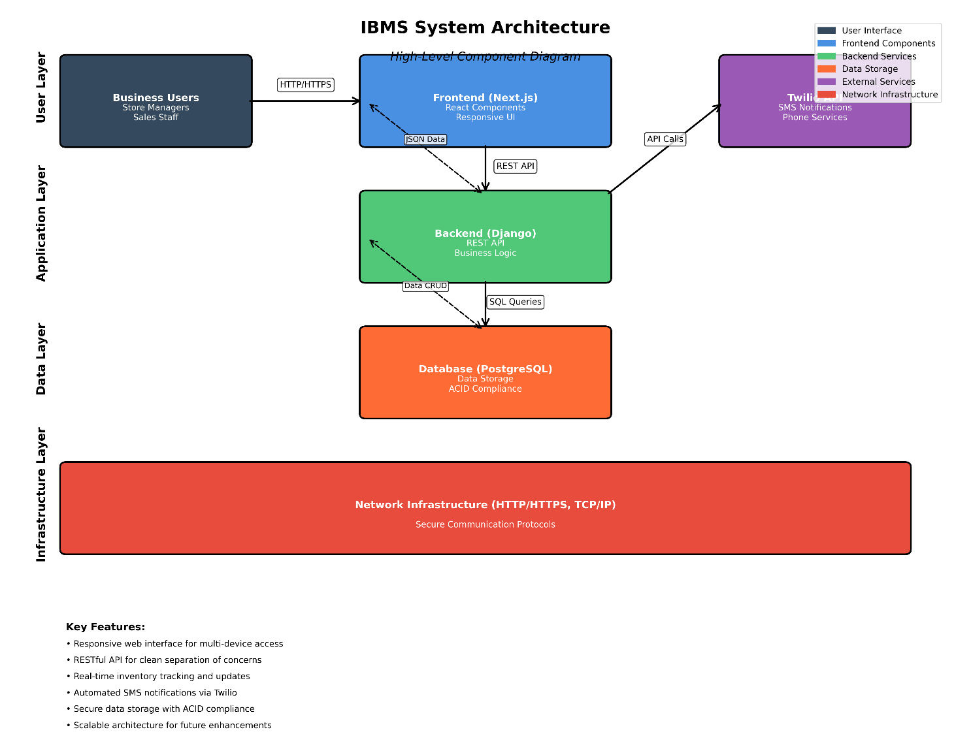

# 6. Future Enhancements/Research Directions

Potential Improvements:

• Multi-location support for businesses with multiple physical stores

• Advanced analytics and business intelligence with predictive modeling

• Mobile application development for iOS and Android platforms

• Integration with popular accounting software (QuickBooks, Xero)

• Advanced reporting with customizable dashboards and data visualization

• Multi-language support for international business operations

• Cloud deployment options with automatic scaling capabilities

• Advanced user role management with granular permissions

• Integration with e-commerce platforms for online sales management

Research Directions:

• Machine learning algorithms for demand forecasting and inventory optimization

• IoT integration for automated inventory tracking and monitoring

• Blockchain technology for supply chain transparency and verification

• AI-powered customer behavior analysis and personalized recommendations

• Natural language processing for voice-activated inventory management

• Advanced data analytics for business performance optimization

• Integration with smart devices for automated inventory updates

# AI Tool Usage Disclosure

This Software Requirements Specification document was primarily developed by the student, Jayakrishnan j(Reg No: 24pmc122) AI tools like cursor and chat-gpt were utilized to assist with brainstorming initial concepts for user roles, non-functional requirements, and for proofreading grammatical errors. All core analysis, detailed requirements, and critical decision-making reflect the original work and understanding of the author.